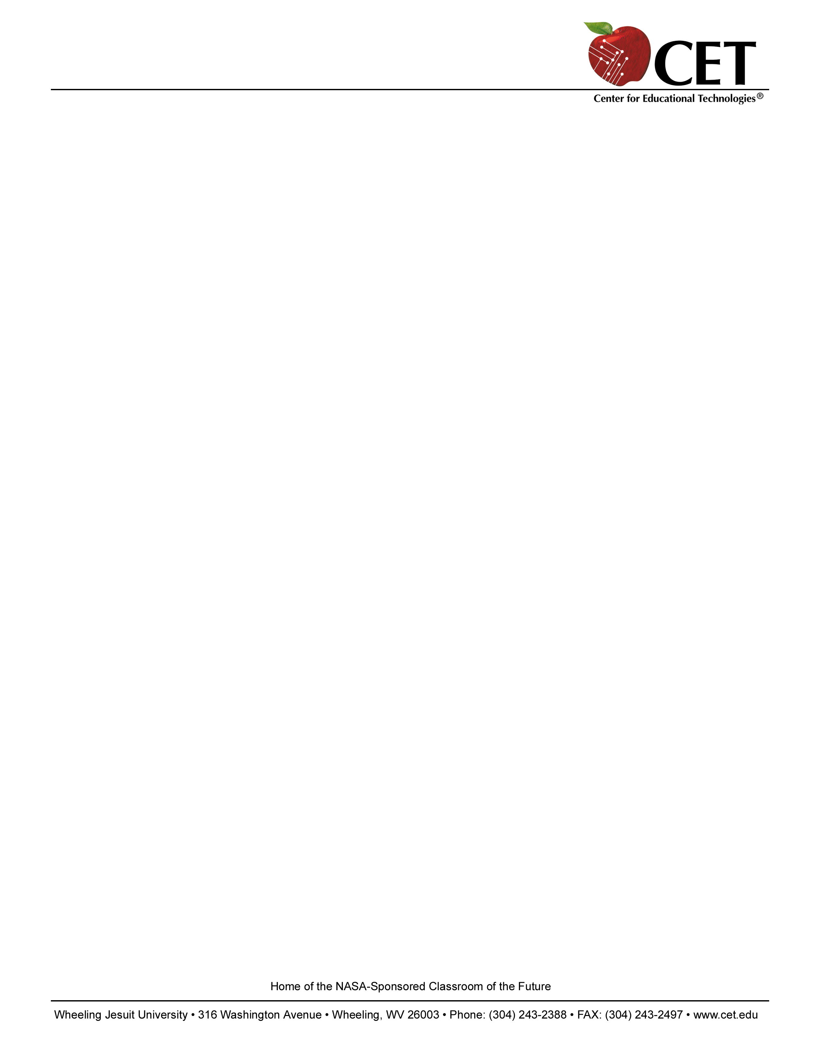
Robotics Workshop for Educators and Youth Group Leaders

Who: Educators and youth group leaders of students ages 9 through 14 and up

What: Learn the basics of building and programming LEGO® robots using the ROBOLAB™ programming language

When: 9 a.m. to 3:30 p.m. on Saturday, September 25, 2004

Where: 21st Century Classroom
Center for Educational Technologies
Wheeling Jesuit University
316 Washington Avenue
Wheeling, WV 26003 (off Interstate 70 Exit 2B)

Contact: Dr. Meri Cummings
Phone: 304-243-2499
Fax: 304-243-2497
E-mail: meri@cet.edu

Registration Deadline: Until Filled – space still available.

There will be a drawing for a robotics kit courtesy of
NASA West Virginia Space Grant Consortium.

***Coffee drinkers, please bring a travel mug with lid.***
Name:

School or Youth Group Name: Age of Students:

Street Address: Grade(s) of Students:
City:
State: Pizza Lunch (choose 1): __Cheese
Zip code: __Pepperoni
Phone: __Vegetarian
Fax: Soda choice:
E-mail:

How do you plan to use the robotics activities learned in this workshop? With how many students?

OPTIONAL: Enclosed is my check payable to LEGO Education to purchase:

1 Team Challenge Robotics set and 1 ROBOLAB software CD with site license $434

1 Robotics Startup pack (4 Team Challenge sets, 1 ROBOLAB and 1 Robotics Educator CD, 4 extra motors, 4 angle sensors, and 1 temperature sensor) $1250.
Prepaid kits will be distributed at the end of the workshop. (Shipping is being waived for preorders.) Call or e-mail if interested in registering a FIRST LEGO League team. A single kit and software can be obtained at a discount when $150 registration is paid.

